**TMHS APPLEFEST**

**CRAFT FAIR**

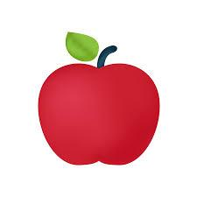

Tewksbury Memorial High School

**Saturday October 26, 2025**

9am-3pm

*Holiday shopping, Quality crafts, food, raffles & more!*

Hosted by the TMHS PAC